EGGLESTON / I’ANSON
PROFESSIONALISM AWARD
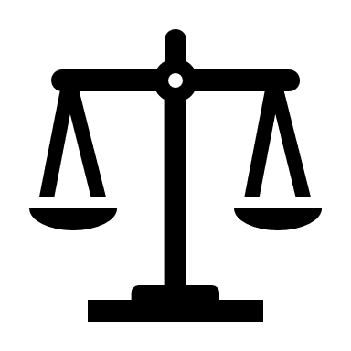
The Norfolk & Portsmouth Bar Association
is accepting written nominations for the

Eggleston / I’Anson Professionalism Award
The award recipient should exemplify, over a substantial period of time,
• Respect for the law, the judicial system and the legal profession
• Respect for clients, court personnel and other counsel
• Honesty, candor, fairness and competence before the court and with counsel.
This award is intended to recognize and honor personal and professional qualities, reputation and conduct. Previous recipients of the NPBA Eggleston/I’Anson Professionalism Award are:

Francis N. Crenshaw
Montgomery Knight
Jr Robert L. O’Donnell
Jack E. Greer
Thomas F. McPhaul
Anita O. Poston
Robert C. Stackhouse
Michael F. Fasanaro, Jr.
Stanley G. Barr, Jr.
John M. Ryan
Howard W. Martin, Jr.
Conrad M. Shumadine
Guilford D. Ware
James A. Metcalfe
Philip N. Davey
Hal Juren
Robert C. Nusbaum
Nathaniel Beaman IV
Charles Tucker
John Y. Richardson
Alan B. Rashkind
Cyrus A. Dolph

NPBA members are encouraged to submit written nomination(s) by March 11, 2022 to:
Norfolk & Portsmouth Bar Association
City of Norfolk Courthouse
150 St. Paul’s Blvd, 2d Fl
Norfolk, VA 23510

Phone: 622-3152
Email: npbamail@gmail.com

Standards and guidelines for selection of the Eggleston/I’Anson Professionalism Award recipient are available at www.norfolkandportsmouthbar.org/Eggleston.html.

